REST Api using JAVA and BDD Cucumber API Testing

<project

xmlns=*"http://maven.apache.org/POM/4.0.0"*

xmlns:xsi=*"http://www.w3.org/2001/XMLSchema-instance"* xsi:schemaLocation=*"http://maven.apache.org/POM/4.0.0 https://maven.apache.org/xsd/maven-4.0.0.xsd"*>

<modelVersion>4.0.0</modelVersion>

<groupId>com.alex.cucumber_api</groupId>

<artifactId>cucumber</artifactId>

<version>0.0.1-SNAPSHOT</version>

<dependencies>

<!-- https://mvnrepository.com/artifact/org.junit.jupiter/junit-jupiter-api -->

<dependency>

<groupId>org.junit.jupiter</groupId>

<artifactId>junit-jupiter-api</artifactId>

<version>5.3.2</version>

<scope>test</scope>

</dependency>

<!-- https://mvnrepository.com/artifact/org.slf4j/slf4j-api -->

<dependency>

<groupId>org.slf4j</groupId>

<artifactId>slf4j-api</artifactId>

<version>1.7.25</version>

</dependency>

<!-- https://mvnrepository.com/artifact/io.cucumber/cucumber-java -->

<dependency>

<groupId>io.cucumber</groupId>

<artifactId>cucumber-java</artifactId>

<version>4.2.0</version>

</dependency>

<!-- https://mvnrepository.com/artifact/io.cucumber/cucumber-junit -->

<dependency>

<groupId>io.cucumber</groupId>

<artifactId>cucumber-junit</artifactId>

<version>4.2.0</version>

<scope>test</scope>

</dependency>

<!-- https://mvnrepository.com/artifact/io.rest-assured/rest-assured -->

<dependency>

<groupId>io.rest-assured</groupId>

<artifactId>rest-assured</artifactId>

<version>3.2.0</version>

<scope>test</scope>

</dependency>

<!-- https://mvnrepository.com/artifact/com.fasterxml.jackson.core/jackson-databind -->

<dependency>

<groupId>com.fasterxml.jackson.core</groupId>

<artifactId>jackson-databind</artifactId>

<version>2.9.7</version>

</dependency>

<!-- https://mvnrepository.com/artifact/org.projectlombok/lombok -->

<dependency>

<groupId>org.projectlombok</groupId>

<artifactId>lombok</artifactId>

<version>1.18.4</version>

<scope>provided</scope>

</dependency>

</dependencies>

</project>

# API requests

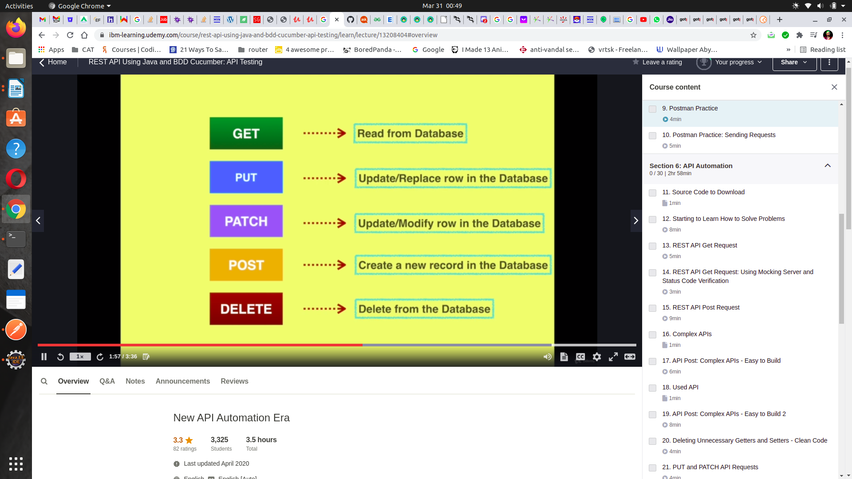

Let's break it into two components:

1) RESTful

2) API

An API is an interface through which one program or web site talks to another. They are used to share data and services, and they come in many different formats and types.

A RESTful API is one of the many possible ways that programs, servers, and web sites can share data and services. REST (Representational State Transfer ) describes the general rules for how the data and services are represented through the API so that other programs will be able to correctly request and receive the data and services that an API makes available

GET*

POST*

Mocking Server ->

<https://jsonplaceholder.typicode.com/>

https://jsonplaceholder.typicode.com/users

Installing PostMan

asteros@asteros-HA-Notebook-PC:~$ sudo snap install postman

Collection ->> new Collection

Add requeest -> ie name = ApiGet

**GET** <https://jsonplaceholder.typicode.com/users/>1

**STATUS: 200 OK**

**Body Cookies Headers TestResult**

**PRETTY**

{

"id": 1,

"name": "Leanne Graham",

"username": "Bret",

"email": "Sincere@april.biz",

"address": {

"street": "Kulas Light",

"suite": "Apt. 556",

"city": "Gwenborough",

"zipcode": "92998-3874",

"geo": {

"lat": "-37.3159",

"lng": "81.1496"

}

},

"phone": "1-770-736-8031 x56442",

"website": "hildegard.org",

"company": {

"name": "Romaguera-Crona",

"catchPhrase": "Multi-layered client-server neural-net",

"bs": "harness real-time e-markets"

}

}

**POST**

body

raw

{

"id": 1,

"name": "Leanne Graham",

"username": "Bret",

"email": "Sincere@april.biz",

"address": {

"street": "Kulas Light",

"suite": "Apt. 556",

"city": "Gwenborough",

"zipcode": "92998-3874",

"geo": {

"lat": "-37.3159",

"lng": "81.1496"

}

},

"phone": "1-770-736-8031 x56442",

"website": "hildegard.org",

"company": {

"name": "Romaguera-Crona",

"catchPhrase": "Multi-layered client-server neural-net",

"bs": "harness real-time e-markets"

}

}

**STATUS: 201 created**

**Body Cookies Headers TestResult**

{

"id": 11

}